ME 423 Engineering Design VII

Phase 3 – Analysis and Engineering Design

**3D Printed Granular Jamming Hand**

**A Senior Report**

**Group #9:**

Melissa Indoe

Chris Kang

Sean Phelan

Maggie Serra

Chris Wallace

**Advisors:**

Robert Chang

Jennifer Field

**STEVENS INSTITUTE OF TECHNOLOGY**

Castle Point On Hudson

Hoboken NJ 07030

(December 2013)

**3D Printed Granular Jamming Hand**

# Abstract

An open-source and primarily 3-D printable hand prosthesis is to be developed by a team of five Mechanical Engineering seniors in a student-driven design project. The hand prosthesis will combine the technologies of existing 3-D printed hands with the concept of granular jamming to maintain a firm grip at a fraction of the cost of existing prostheses. The hand will allow for performance of relatively low strength, high dexterity, everyday tasks. To meet this goal, a background of types and incidences of amputation has been established, as well as of state-of-the-art designs in both professional and hobbyist prostheses. Potential users of the product have been identified, and some original research on hand usage has already been completed. Additionally, conceptual designs have been generated and compared, resulting in a generalized plan for future hand design, and a plan for future testing and development has been generated.

**Authors:** Melissa Indoe, Chris Kang, Sean Phelan, Maggie Serra and Chris Wallace

**Advisors:** Robert Chang and Jennifer Field

**Department:** The Department of Mechanical Engineering

Table of Contents

Abstract 2

Introduction 4

Project Objective 4

Project Background 4

Problem Statement 5

Project Impact 5

Deliverables for Next Semester 6

Technical Analysis: 6

Analytical Analysis: 7

Force Analysis on Rubber Bands 7

Force Analysis on a Finger 8

Granular Jamming Analysis 10

SolidWorks Analysis 10

Joint Pin Analysis 10

Physical Testing 16

Manufacturability Testing 16

Motion Testing 18

Granular Jamming Testing 20

Project Review 22

Engineering Design 23

Electrical Considerations 26

Control Considerations 29

Safety Considerations 30

Professional Drawings/Assembly Models 31

Gantt Chart 35

Nugget Chart 36

Bill of Materials 38

Works Cited 39

# Introduction

## Project Objective

The project objective is to create an open-source, high-functioning, affordable, 3-D printed prosthetic hand. The prosthesis will be task oriented and able to perform simple activities requiring low strength and high dexterity. The hand will be the same size and weight as the average human hand, along with looking as human as possible. It will be designed for a patient who has lost an arm below the elbow. Along with the hand design, mounts will be made for an existing forearm housing which will hold the motors, vacuum, and valve. This simple design will allow other users to take the prosthetic, which is open-source, and make whatever modifications they desire, whether for control, aesthetics, or for a prosthetic that could be developed to be above the elbow or even to the shoulder. Several major issues in this project include maintaining dexterity of the fingers, device durability, and keeping the device affordable and the parts easily attainable.

There are several primary goals for the prosthetic hand. It will be able to pick up, hold, and put down objects of various sizes and shapes. It will also open and close different sized doors, from knobs to refrigerators. The prosthesis will be able to make simple hand gestures, including “thumbs up” and pointing, and will also be able to use a computer mouse. While the hand may not be complex enough for the use of traditional utensils, it will be able to hold occupational therapy tools, including cutlery and writing utensils. If the prosthesis can complete most of these tasks, the project will be a success and can prove very useful in day-to-day life.

The secondary goals for the project are slightly more complex. The group is considering incorporating pads on the fingers for touch screens on tablets or laptops. This could be accomplished using a conductive layer on thumb and index finger. Also, the group is considering if the index finger can be made strong enough to open pop-top cans. These goals are not a project priority, but add useful dimensions to the project. These are goals to attempt once the primary goals are achieved.

## Project Background

There are approximately 12,500 arm amputations each year in the United States. Seventy-seven percent of these amputations are due to trauma (Kulley). While the amputation types may vary, from forequarter amputation (at the shoulder), transhumeral (above the elbow), and transradial (below the elbow or lower), Transradial amputations are the most common, occurring in 44% of all amputations (Freeland).

There are many prosthetic and mechanical arms available today, but all have their shortcomings. One type of prosthetic is a hook operated by cables attached to the shoulder, which can control grasp by shrugging the shoulder. However, these devices make inaccurate motions and grasps, and can be expensive and uncomfortable. There are also more advanced prosthetic hands, controlled by myoelectric sensors, which are even more expensive and heavy. The myoelectric arms weigh 2 to 3 times more than the cable arms and cost at least $11,000 (often not covered by insurance).

Amputations are a global problem, and many developing countries do not have access to even the simplest prostheses. It is estimated that only half of all arm amputees get access to prostheses (Kulley). Individuals in these underdeveloped or war torn countries are often left handicapped with no access to help.

The project will help to overcome these challenges and limitations. The hand will be 3-D printed, lowering both cost and weight. The control system for the prosthesis will include a simple control system, with four motors and four Hall Effect sensors, and also a granular jamming pad in the palm. Granular jamming is the use of small pieces of material in balloons. When air is removed from the balloon, the balloon is able to grip the objects. This helps the hand hold objects better. This combination will create a low-cost alternative for the current myoelectric hands, sacrificing some freedom and complex control without greatly affecting the usability, due to the increased functionality of the granular jamming pads.

The hand will be designed though open-source software so anyone with access to a 3-D printer can print out the prosthesis. This saves on cost; instead of having expensive centralized manufacturing and shipping costs. A prosthetic hand could easily be made at home by a user and could be customized because the designing software is open source, opening many possibilities for humanitarian aid.

## Problem Statement

There are thousands of arm amputations happening each year around the world, and loss of an arm can severely limit a person’s independence. Current prostheses can restore functionality to the missing limb of the amputee, but are not available to many people globally due to cost and availability. Therefore, there is a need to create an inexpensive and readily available prosthesis for amputees around the world.

## Project Impact

Development of an open-source, inexpensive, and easy to assemble prosthetic could have a potentially huge impact on those without access to traditional prosthetics (either due to cost or to lack of access to state-of-the-art medical facilities). This prosthesis can give people in developing countries access to technology they have never been able to attain before. By creating an inexpensive and easily created and customized robotic arm, humanitarian aid groups could produce prosthetics on a case-by-case basis, customizing them for individuals without having to go through the many steps of measuring, manufacturing overseas, and shipping. These prosthetics therefore would drastically save on cost and lead time, meaning that more people can be helped with the same amount of time and money. By developing this inexpensive and easily created robotic arm, many people will be able to better live their everyday lives. Therefore this project could have a huge impact on people who are prohibited from accessing standard medical care due to cost or to living in a country with no substantial medical system (due to widespread poverty or political reasons).

In addition to the enormous potential benefit to amputees, this project is also very “green” and environmentally friendly. It is designed to be mainly 3-D printed and can be produced in either ABS or PLA plastics. ABS plastic is totally recyclable (and in fact it would be feasible to make the arm itself out of recycled plastic with the right equipment) and PLA is actually made from corn, rather than petroleum, making it extremely sustainable (and meaning that it does not release potentially unhealthy fumes while printing, as ABS can). Additionally the method for 3-D printing plastic just involves fairly low heat, and electricity, as opposed to industrial processes which can be far less environmentally friendly. It would even be totally feasible to power the printer with a small human-powered generator or with solar panels. Making the hand on-site instead of ordering one also drastically reduces waste and pollution due to shipping (since the hand needs no packaging, and does not require gas, airplane fuel, etc for its transport).

The design of the hand is also totally modular. In order to create housing for, say, a motor, a box is generated in OpenSCAD and then a motor model is subtracted from that box. As a result it is very simple to get the hand to meet different design standards. For example, if the motor used in the original design has been discontinued, or if a better or cheaper model has been found, all that the designer needs to do is edit the motor model in OpenSCAD with its new dimensions. Because of the modularity of the design, all motor housings will then scale to fit and the entire arm can be updated by repairing just one part file.

In addition, the arm could be used as a standalone project to perform dangerous tasks such as handling hazardous materials or caring for sick babies in incubators. It could also be used in automation in the manufacturing industry. Being able to mimic a human hand would greatly benefit an assembly line or standardized process. Also, since this project is open source, people are free to modify it to fit their needs, opening whole new realms of possibilities.

## Deliverables for Next Semester

Next semester will mark the conclusion of this project. In that time, the group must accomplish many things. The website for this prosthesis has been started and will be completed in Phase 4. A final design has been completed and parts will be ordered before the end of the semester. Upon receipt of these parts, a prototype must be built, tested, and improved. We will continue iteratively designing project elements to develop the best possible prosthesis, and at the end of the semester, the hand will be complete and fully functional.

# Technical Analysis:

Basic design ideas were generated during Phase 1. During Phase 2, these ideas were then tested and revisited as necessary to solve any issues with their application. In order to properly carry out this analysis, potential trouble spots were defined. These major areas of concern included strength and manufacturability of the printed joint pins, forces incurred by rubber bands during bending of the fingers (first ascertaining if they would snap when the hand was closed, and then determining the number of cycles to failure—since if it was too low the rubber bands would break often, an unacceptable scenario), materials considerations (whether ABS plastic would be strong enough for the arm or if polycarbonate plastic would be necessary), and granular jamming efficacy (first to see if the granular jamming pads added enough functionality to justify, then to determine if there is enough surface area on the hand to actually improve grip, and finally to see if the vacuum would be able to reach granular jamming phase transition in a timely manner). These areas were analyzed either analytically, via SolidWorks models, or via physical tests.

Additionally, some of these technical analyses refer to “standard working condition”. Standard working condition is defined by the hand under maximum power by the motors. Under the system’s own power these are the maximum forces that the hand can encounter. Obviously there are cases where external forces can interact with the hand, possibly crushing fingers inward or bending them backward, but these forces are addressed separately.

## Analytical Analysis:

### Force Analysis on Rubber Bands

In the proposed design, the fingers are being held straight with rubber bands at all the joints. Rubber bands are relatively fragile and prone to snapping. If the hand is going to be effective, the rubber bands need to be able to withstand the fingers bending hundreds of times throughout the day. To ensure that their solution would work, the group found the static load failure and the fatigue failure over bending cycles.

First the static load was found. This static load is defined as the load on the rubber band when the hand is in a neutral (flat, not bent) state. It is to see if the act of placing the rubber bands into might cause them to snap. For this calculation, maximum shear stress of rubber was then found using the cross section of an actual rubber band (about 1mm2). Yield stress of rubber was found to be about 500,000 MPa. K of the rubber band was estimated to be 10 N/m via research.

***Static holding force:***

*τmax=Sy/2* = 1MPa/2= 500,000 MPa

*τactual=F/(cross section)*

F = force needed to stretch the rubber band 4mm

*F=kx*=(10 N/m)*(.004 m)

F=.04 N

*τactual=F/(cross section)*

=.04/(.001)2 = 40,000

(well under maximum shear)

FOS=*τmax*/*τactual*= 12.5

The actual stress is safe and well below the maximum shear stress. This means that in a neutral state, the bands will not snap due to being stretched around their housings. However this does not calculate forces when the finger is bent. Therefore, a fatigue analysis was performed to determine how many times the finger could be bent before failure.

For these calculations, ultimate stress of rubber was found to be about 15 Mpa, and the factor determining endurance limit was set to 0.2, since rubber is extremely pliable and prone to tearing, especially around the sharp edges of the joints, creating a lot of surface irregularities. The group set fatigue as stress incurred via stretching the rubber bands 12mm (the amount the bands are stretched when the finger is fully bent). The group then solved for the endurance limit, ultimate strength, and the coefficients A and B.

***Number of cycles to failure:***

*Sf=aNb*

*a=(f*Sult)2/Se*

*b=(-1/3)log(f*Sult/Se)*

Sult=15 MPa

Se=Sult*0.2 = (15 MPa)*0.2 = 3 MPa

a=(.8*15MPa)2/(3MPa)=48000000

b=(-1/3)log((.8*15MPa)/(3MPa))=-0.462

F=kx=10*(.012) = 0.12

Sf =F/(cross section) = 0.12/(.001)2

Sf = 120000

Sf= aNb

120000 = 48000000*N-0.462 **N=4.29*105 cycles**

After solving the equations, the rubber band was found to last 429,000 cycles. This was determined to be more than efficient enough for each of the fingers. This does not account for effects such as the defects on the rubber band surface or the stress concentration of being pulled into a rectangular shape, but as a preliminary analysis it seems to show that these are going to last an appropriate amount of time with repeated finger bending.

### Force Analysis on a Finger

An important piece of this project is the material in which the hand is printed. To help with material selection, the team did an analytical analysis of a force on a finger. The finger was modeled as a static body using a square cross section. A force of 2 kilograms was chosen. This was chosen because if the whole hand was carrying a grocery bag or briefcase, the force would be distributed to the four fingers. This means the 2 kilogram force on one finger is equivalent to 8 kilograms held by the whole hand. The team decided this was a sufficient weight to symbolize what someone would carry.

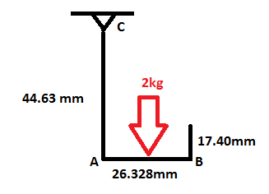

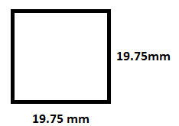

**Static model Cross section**

First, the group calculated the moment about A to be used in the bending moment equation.

M=Force x Distance

M=(2 kg*9.81 m/s2) x (0.026328 m / 2)= 0.258 Nm

Then, the group calculated the bending stress.

σb= My/I

I=b4/12 = (0.01975m)4 /12 = 1.27 x 10-8m4

σb= (0.258Nm)(0.01975m/2) / 1.27 x 10-8m4

σb= 200.3 kPa

Next, they calculated the maximum shear stress in segment AB.

Ʈ=3F/2bh

Ʈ =[3(2kg*9.81m/s2) / 2(0.01975m)2] = 75.4 kPa

Finally, the group calculated the normal stress in segment AC.

σn= F/A

σn= (2 kg*9.81 m/s2) / (0.01975m)2 = 51.3 kPa

After the individual stresses were calculated, it was necessary to find the maximum total stress. It was determined that maximum stress would occur on the inside of segment AC, because the bending stress and normal stresses are additive.

σmax = σb + σn σmax = 200.3 kPa + 51.3 kPaσmax = 251.6 kPa

This is significantly less than the yield strength for ABS plastic (44 MPa).

#### **Granular Jamming Analysis**

To model the granular jamming pad, the team needed specifics on the operations of the granular jamming system. Based on the article “Universal Robotic Gripper Based on the Jamming of Granular Material” by Browna et al a change of pressure of 75 kPa is sufficient to pick up objects. The team sourced a pump with this pressure differential. Using this pump, the team then found the diameter size tubing that would be needed to hold up an object. The following shows the details:

***Force on object***

Assuming object to be held is 1 lb (0.453 kg)

ΔP= 75kPa

F=P*A

0.453kg=75000Pa*(πr2)

Diameter=8.7mm - 10mm standard tubing will be used.

Next the team wanted to make sure that the amount of time it takes to remove air from the pad would not be too long (since it is unrealistic to expect the user to wait a few minutes just to pick something up), so we calculated evacuation time using specifications from the pump chosen.

***Evacuation time***

q = 3.659*10-5 m3/s

V = 3.659*10-5 m3

P0 =1013.25 mbar

P1 = 266.25 mbar

t = V/q * ln (P0/P1)

t = 0.652 seconds

Evacuation time is under a second, so both calculations resulted in reasonable outcomes.

## **SolidWorks Analysis**

Joint Pin Analysis One major area of concern for the proposed design was its printed joint pins. Printing plastic joint pins, rather than inserting metal ones, would allow for the design to be produced in one piece, making it a non-assembly model. This would drastically cut down on time and training required to create the prosthetic hand, as well as differentiate the design from existing open-source devices.

Joint pins made this way would be weaker than metal pins, but given the hands purpose, for performance of everyday activities, and the strength of the motors and actuators involved, there is no real reason to seek out the extra strength of metal pins if plastic is adequate (even in the case of impact or twisting of the fingers, most of the force is distributed around the joint interfaces, not within the pins). To assess strength of the pins, a model was created in OpenSCAD and was then imported into SolidWorks for analysis.

The model generated was considered a “rough draft”, modeling only the middle (longest) finger, with correct finger segment lengths, hinge placements, and joint pin sizes. This model did not include the final iteration of the cable guides, nor various aesthetic features (to be added in later).

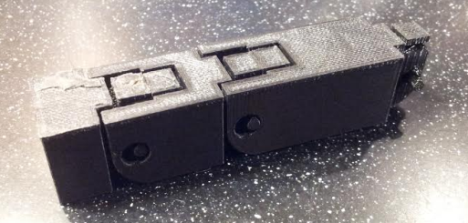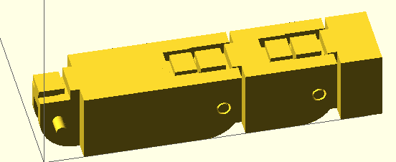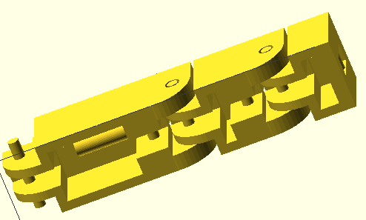

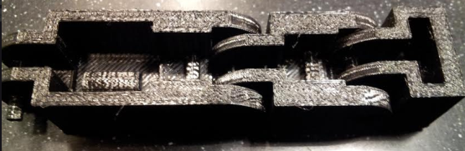

Figure 1: Base Finger Model. Top view (top left) and bottom view (top right) Printed model is displayed below.

This model was then exported as three separate .stl files (one for the fingertip segment, one for the fingermid segment, one for the fingerbase segment), the geometry was fixed using Netfabb’s online cloud service, and it was imported into SolidWorks (using the “solid body” condition). Once in SolidWorks, a few changes had to be made to get it to run with SolidWorks’ solvers. First it was run through SolidWorks’ import diagnostics and then was converted to SolidWorks features using the FeatureWorks “Recognize Features” option. A force analysis could be performed on the finger segments once all of this was completed.

The force analysis was first run on the fingertip, with force applied at the bar where the driving cable would be tied. Force was defined as 4.5 Newtons, the maximum torque of the selected servo motor. The joint pins were defined as fixed geometry since pulling the wire inward would grind the joint pins against the joint pin holes of the next segment.

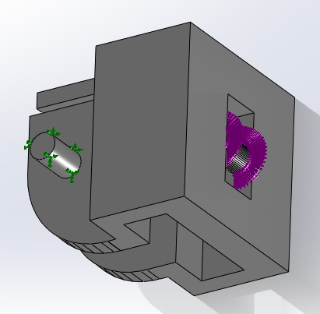

Figure 2: Force application at the fingertip. The purple arrows indicate where force is applied (along the front, top, and bottom portions of the bar) and the green arrows indicate fixed geometry (the joint pins).

This analysis was performed first using ABS plastic as the material. This material was available from the SolidWorks library but yield strength had to be sourced elsewhere. (Unknown—ABS data sheet)

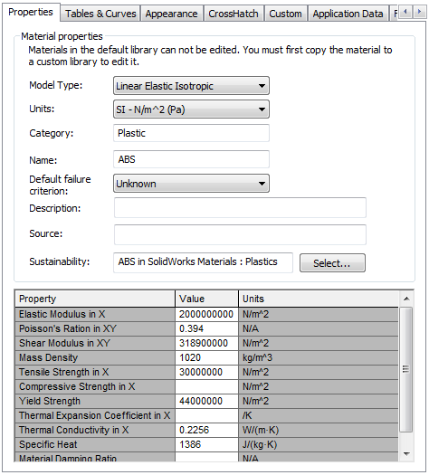

Figure 3: ABS material properties used.

Running the analysis showed that ABS passed the standard working condition requirements with flying colors. Maximum stress in the segment was found to be 0.58 MPa, concentrated around the base of the joint pins (as expected). “Failure” was defined as reaching the yield strength of ABS plastic (44 MPa) since any force large enough to cause plastic deformation of the pins would prevent them from rolling properly in their joints. This yielded a factor of safety of 75.5 for the fingertip segment.

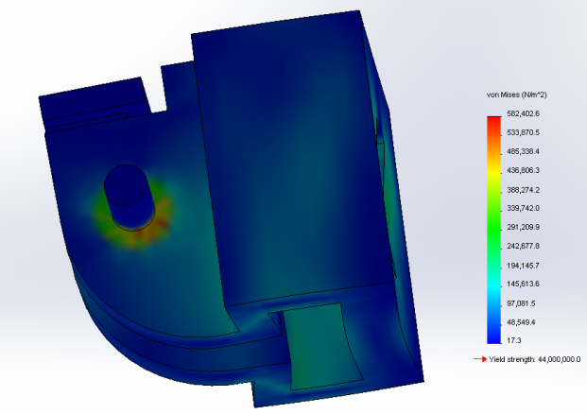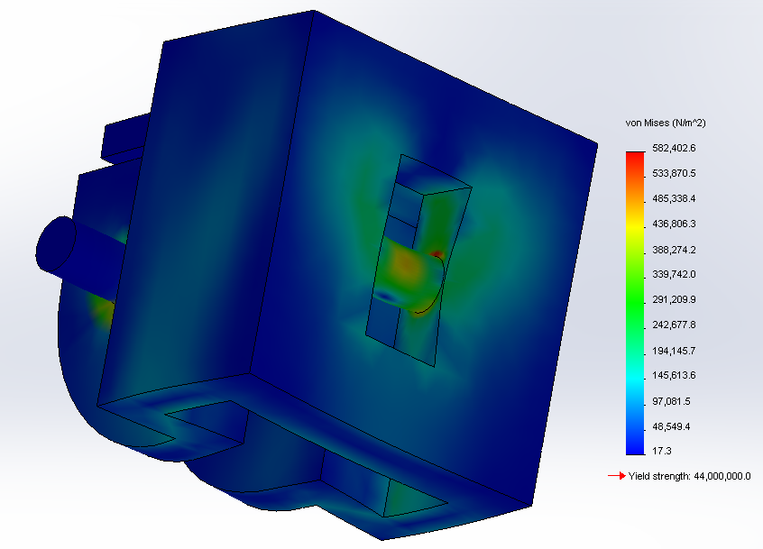Figure 4: Views showing Von Mises stress and deformation at the connection bar (left) and at the joint pins (right). Note that deformation is greatly exaggerated (scaled up by a factor of about 450) in order to be visible.

This analysis was then repeated for the middle and base finger segments. For these segments the force application was along the bottom and back of the joint holes and along the front and top of the wire guide. The joint pins were again defined as fixed points. The force was defined as 4.5 Newtons, spread evenly over points of contact.

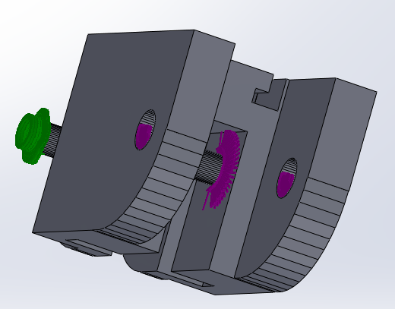

Figure 5: Force application at the middle segment. The purple arrows indicate where force is applied (the joint interface and wire guide) and the green arrows indicate fixed geometry (the joint pins).

Figure 6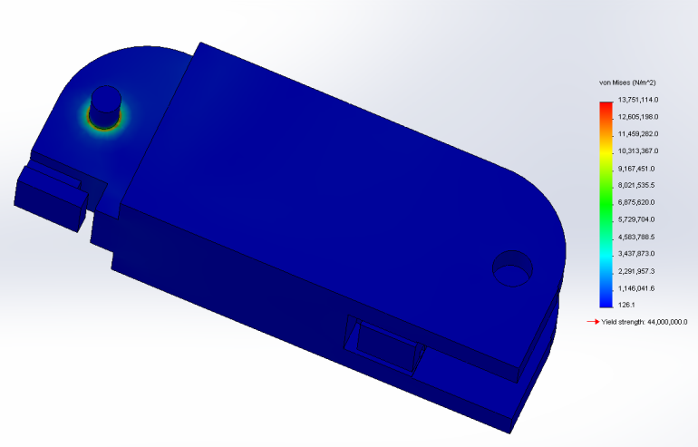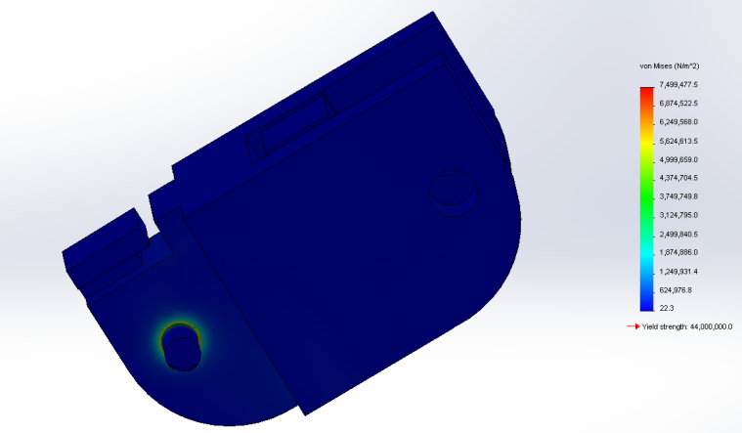: Middle (left) and base (right) segment Von Mises stresses, showing that stresses are again concentrated at the base of the joint pins.

Maximum stress was found to be 7.5 MPa for the middle segment and 13.8 MPa for the base. This yielded an overall factor of safety of 3.2, more than reasonable (especially when considering that the force will probably be more distributed when the hand is actually used—the simulation assumes that motor force is applied equally to each finger segment and that each segment receives maximum possible force).

Since the joint pin analysis showed that ABS passed use cases, the idea of printing in polycarbonate plastic could be eliminated, since the extra strength would not be necessary for the scope of the project. This eliminates a great deal of cost and complexity. Additionally, since ABS proved more than adequate, PLA (a weaker plastic) was also tested (PLA is more environmentally friendly than ABS, since it is made entirely from plant material, and releases no toxic fumes while printing). PLA was not included in the SolidWorks Materials Library, so a new material had to be defined. Values were obtained from (Polylactic Acid) and (Brown).

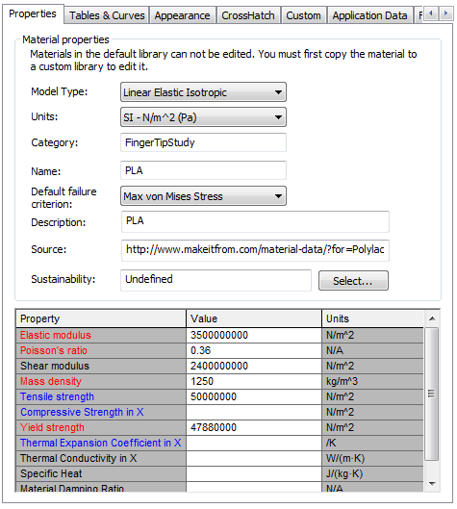

Figure 7: PLA material properties used.

Running the joint pin analysis with PLA showed that maximum stress during working conditions occurred at the base segment again and totaled 13.8 MPa, yielding a factor of safety of 3.5 (as yield stress of PLA is 47.8 MPa). This concludes that under working conditions both materials were completely suitable.

In an attempt to differentiate more between PLA and ABS plastics, a test of ultimate strength was performed. For this load to failure test, the base segment was modeled as if the finger was being bent backward.



Figure 8: Failure testing scenario. (Image source: Astley)

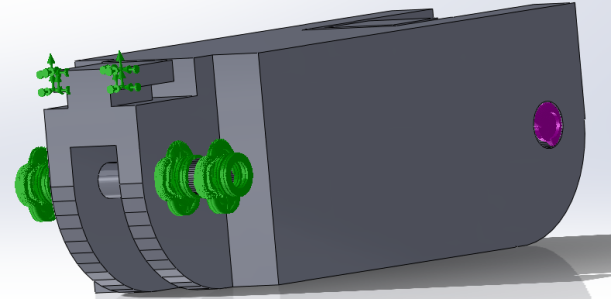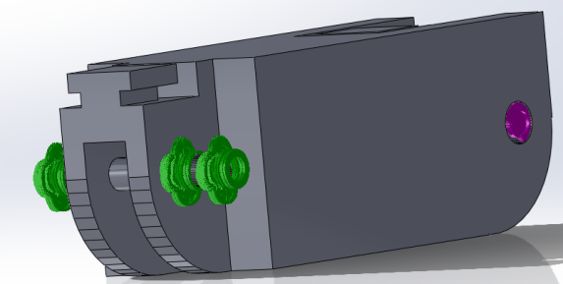This model only examined the joint pins at the base of the finger, since that is where the most force would be concentrated (due to the rest of the finger acting as a moment arm). Two tests were run: a worst case scenario (where all force was transmitted to the joint pins) and a realistic scenario (where force was transmitted to the joint pins and at the top edge of the joint). Force was applied the same way as for the standard use models, and was steadily increased until yield failure occurred.

Figure 9: Worst case (left) and realistic (right) diagrams of force application (purple) and fixed position (green).

In the worst case scenario, both materials failed at just under 15 Newtons. While this value is fairly low, in the realistic scenario, ABS failed at about 40 Newtons, and PLA failed at about 43 Newtons, which was much more reasonable. Therefore the load-to-failure test found that both materials were comparable (and that either way the finger wouldn’t be too fragile).

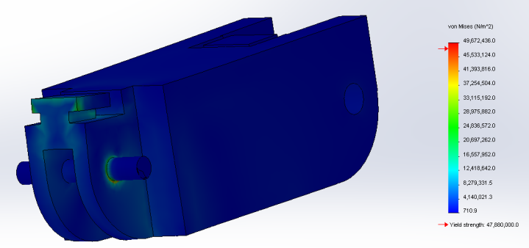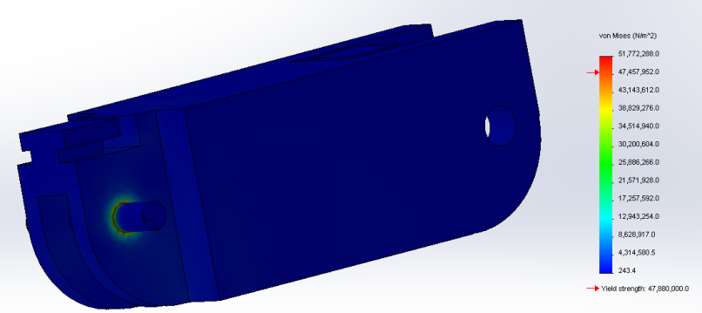

Figure 10: Worst case (left) and realistic (right) stress distributions.

Therefore, the conclusion for the joint pin analysis was that polycarbonate plastic could be eliminated from the design, both PLA and ABS plastics would be mechanically suitable for the final design (though ABS may be a better choice due to impact resistance and wear issues), and that the printed joint pins were a completely viable choice (at least in respect to forces incurred under working conditions and force required for failure), and would not need to be replaced with metal ones.

## Physical Testing

### Manufacturability Testing

While the joint pin analysis found the pins mechanically viable, there was still one major design issue with them. The joint pins must “float” in midair during printing, they are small features, with relatively high tolerance, requiring the 3D printer to lay filament with no support material.

Typically when 3D printers must print overhangs more than 45 degrees, they must lay out support material to prevent the filament from sagging. Usually this consists of fragile layers that are designed to break off easily, but inside the finger joints there is not enough space to clean these out. The other type of support material is sacrificial material, a different material from the structure, one with different chemical properties that will dissolve in water or a weak acid/base. While it is reasonable to design with sacrificial material in commercial 3D printers, for small-scale printers like the ones our target users will have access to, it is not common. Most consumer 3D printers only have one extruder (though dual extruder models, capable of laying down sacrificial material, do exist).

Therefore, if the joint pins are too large to print as overhanging geometry, with no support material, then they will not be suitable for the final product (despite working well in the force analysis). However, part of the draw of 3D printing is that material is extremely inexpensive and readily accessible, and that manufacture requires almost no labor. This means that a project like this one can be printed at an early stage in development, dealing with many manufacturing issues early on. Therefore, the best test of print viability is to physically print the finger.

The finger was first printed on a PrintrBot Plus. The print weighed 27 grams in total, and used about 84 cents worth of material. It took only 30 minutes to complete a print of one finger, which was well within reasonable time constraint for prosthesis manufacturing—it is reasonable to assume that one prosthesis should take approximately 20 hours to prin.

The first print was a failure, which should be expected given how much calibration and iteration 3D printing generally requires. It failed because the tolerances at joint interface were set too low, causing the segments to bridge together and make a completely rigid structure (tolerance at the joint interface was set to 0.5 mm, well above the 0.04 mm that the printer should be capable of. However, given how consumer 3D printers are an emerging technology, they are not always consistent). The joint pins suffered from the same issue, bridging the gap between themselves and the joint pin holes. Though it was hard to see from the first model, the pins also appeared to be too warped for the design to function.

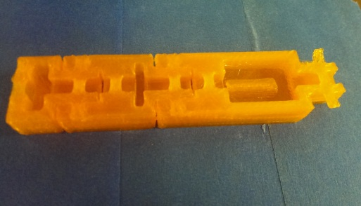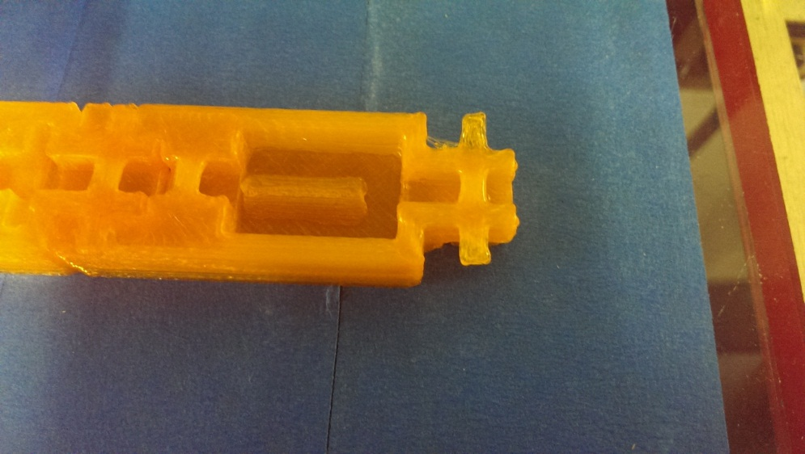Figure 11: Points of failure: The joint pins (left) are too rough for a plastic-on-plastic joint interface. Joint tolerance (right) is too low, plastic has bridged the points of articulation and the finger is solid.

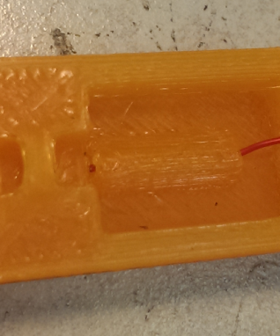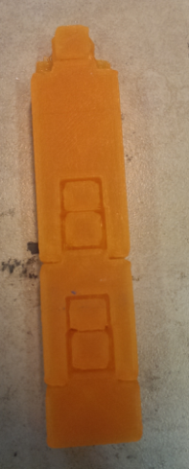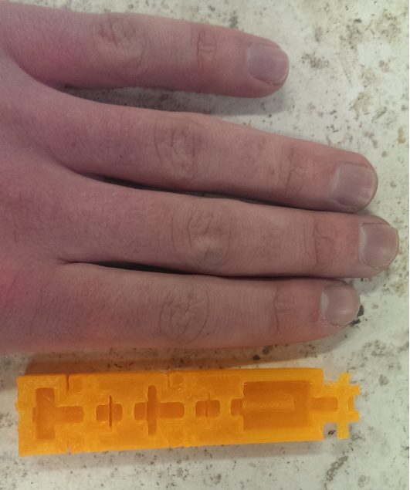Positive points of the initial print were also identified. Aside from the required tolerance adjustments, the rubber band guides (which also have slight overhangs) printed successfully, scaling was perfect (exactly the proportions of a human finger) and other small features, such as the wire guide, printed properly.

Figure 12: Positive points: the scaling (left), rubber band guides (center) and wire guides (right) are all correct and functional.

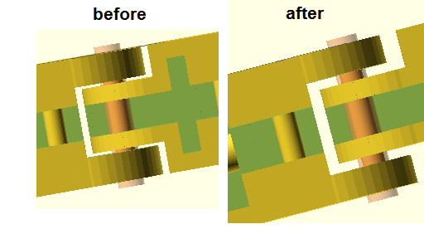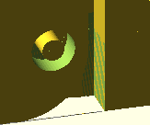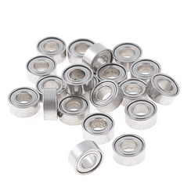Based on these initial findings, it is be completely reasonable to use 3D printing as the method of manufacture provided that the joint clearances and joint pin clearances are larger. The model was then modified for these new adjustments. Joint clearance was greatly increased, and bearings were added to the design to solve both the problems of joint pin clearance and joint pin warpage in one step. Since these plastics are designed to be melted and extruded, they are very pliable when hot. Therefore, by making large joint holes suitable for accommodating a bearing, and then applying a heatgun briefly before pressing the bearing into the space, a 2mm printer clearance can be added, solving the bridging problem, and the joint pin has been forced into the bearing hole, solving the slight warping issue.

Figure 13: Left to right: Improved joint clearances, bearings, bearing clearance. (Image Source: 20 Pcs)

After these changes were made, another test print was performed, showing that the changes had fixed all manufacturing issues. Increasing the tolerance had prevented the joints from fusing and the extra space for the bearings had prevented the joint pins from failing.

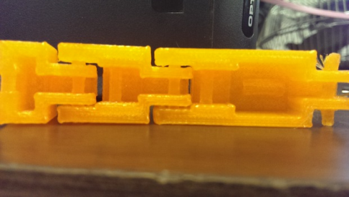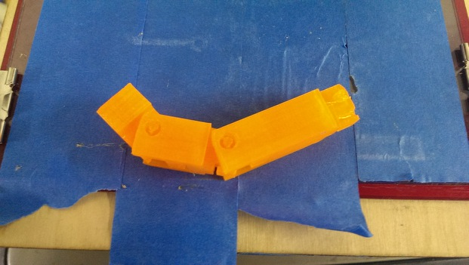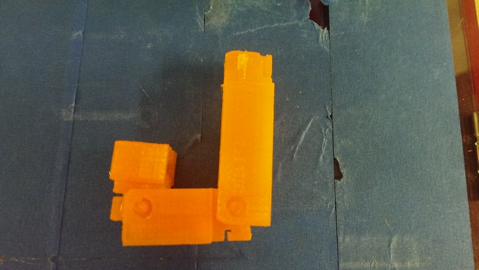Figure 14: Joints are now functional and joint pin problem has been solved.

The conclusion from this manufacturability analysis is that the finger can be printed as a non-assembly model as long as tolerances are made large enough, and as long as measures can be taken to prevent excessive warping in the joint pins. Without bearings, the finger is functional although it does tend to rattle. It can even be possible to add bearings on a case-by-case basis, where hands with relatively non-warped pins can be provided as-is, and those with slight defects can be corrected with bearings. Regardless, there seems to be no issue with printing the finger as it is currently designed, and therefore design can move forward while assuming that the joint pins are plastic, and that the model is printed in one piece.

### Motion Testing

Once it was established that the finger could be manufactured properly, it was then necessary to refine the design so that it could bend completely (90 degrees at each joint, just like a human finger) and so that it would bend properly when the cables were reeled in. The design as it stood after manufacturability analysis could only bend at just under 90 degrees at each joint due to telebanking issues. Additionally the cable guides caused force to be too much in line with the joint interfaces, meaning that motor torque was mostly getting applied to grinding the joints together, rather than bending them downward.

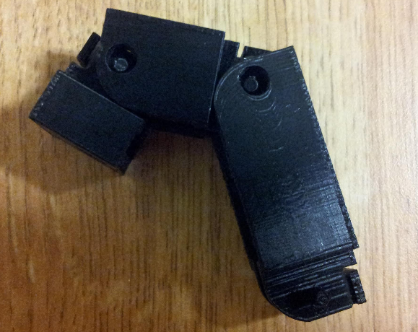

Figure 15: Finger at maximum bent position

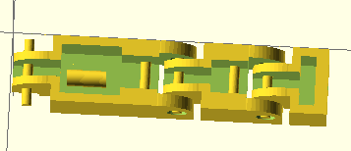 In order to fix this, the joints were more rounded in OpenScad, both to decrease interference and to make the finger more aesthetically appealing (appearing more like a real, human finger, and a little less blocky), and the cable guides were completely reworked. The middle segment cable guide was moved downward (i.e. away from the knuckle) and backward (i.e. toward the arm), to achieve a better lever arm, and the base cable guide was replaced by three guides, two at the bottom of the segment and one near the top.

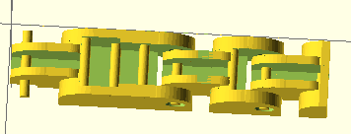

Figure 16: previous finger iteration (left) with half-rounded edges and old style cable guides, and new finger iteration (right).

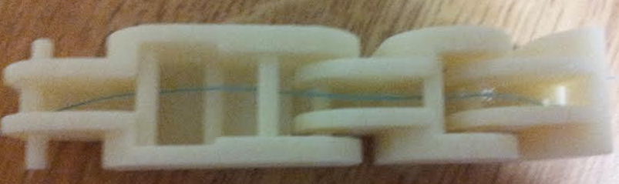After a little trial and error cabling this new segment, a cabling scheme was found that offered an extremely realistic range of motion, causing the prosthetic finger to bend first at the middle joint, and then at the top joint, just like when a real finger is curled inward.

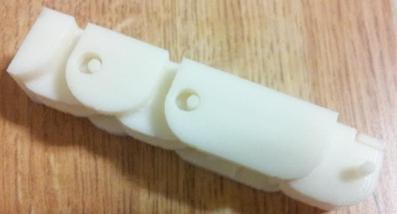

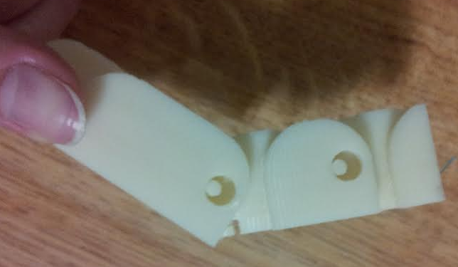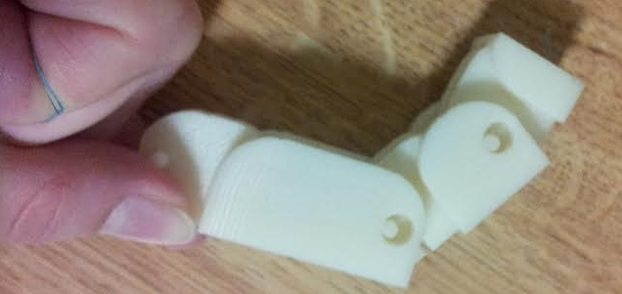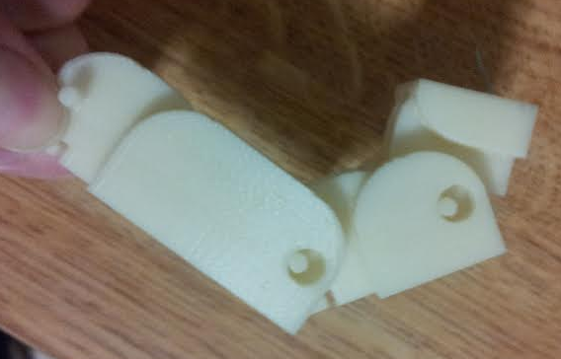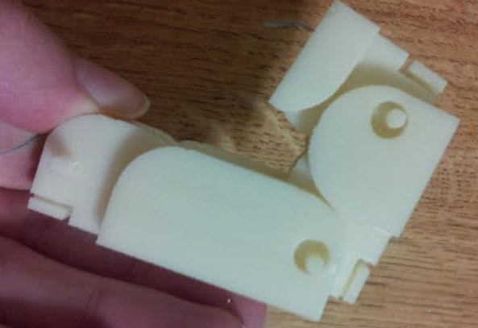

Figure 17: New design and cabling scheme (top row) and motion progression when string is pulled (bottom row).

After this successful motion analysis it is now safe to say that the finger design is complete. There are models in progress for the palm and forearm that may need further iterative design (since things can be modeled indefinitely but often when they are manufactured new issues arise and slight design adjustments will always have to be made) but all points of design in the fingers have been worked out, and the finger design, at least, is totally complete. Elements of the palm and forearm design will be visited later in engineering design and assembly models.

### Granular Jamming Testing

One other major aspect of the design is granular jamming technology. The concept of granular jamming is that small particles in a flexible container become rigid when they are tightly packed together. Granular jamming application makes the hand capable of picking up relatively small objects. Picking up objects is done by pressing a pad on the object, jamming the granules by using a vacuum to remove air from the pad, and then lifting the object with the pad.

To verify plausibility of applying granular jamming technology to the fingers and palm of the prosthetic hand, a simple test was done. The test materials included balloons, coffee grounds, plastic beans, coffee filters, a vacuum, and objects to be picked up including a pen, pill container, and a glass.

***Procedure:***

First, a balloon was filled with plastic beans so that the balloon was approximately 60-70% filled. A second balloon was also filled to the same approximate level with coffee grounds. Next, the vacuum hose was covered with a coffee filter. Then, the balloon was stretched over the vacuum hose which is covered with the coffee filter. The balloon was pressed on to various objects, and the vacuum was turned on. The balloon was then raised to see how well it could pick up the object. This was then repeated with the balloon filled with coffee grounds.

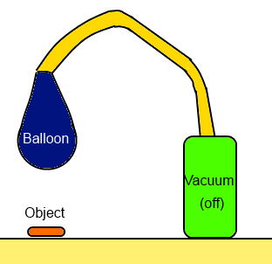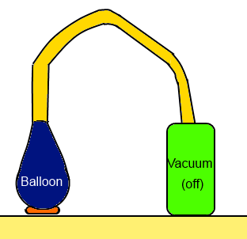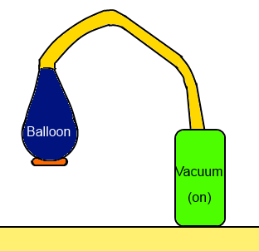

Figure 18: Illustration of testing setup

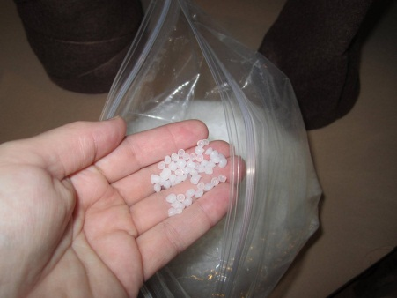

Figure 19: Materials used: Plastic beads (left) and coarse ground coffee (right) (Image source: “Unknown” –Image source 1, “Unknown”—Image source 2)

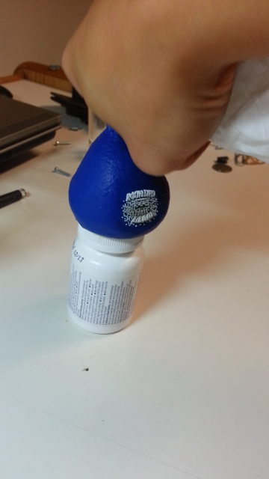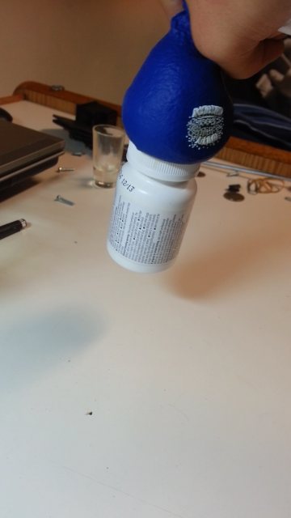

Figure 20: Balloon being fitted around a pill bottle Figure 21: Picking up pill bottle with the balloon

Several things were observed during testing. First, the team saw first-hand that granular jamming can consistently pick up various household objects. Additionally, it was determined that coffee grounds were better for picking up objects than the plastic beans (something which has confirmed what we expected—so far in granular jamming research coffee grounds have actually been accepted as the most effective granular jamming material).

The reason why coffee grounds worked better is because the granule size of ground coffee is much smaller and more variable than that of the plastic beans. Smaller particles can more easily wrap around an object, and variable sizes means that smaller material grains can jam between larger ones, creating a much more solid transition. The coffee grounds also have a rougher surface area than the beads, meaning that they create more friction as they pass each other, also aiding in the transition.

Finally, it was observed that the balloon could only pick up objects when it had a large amount of contact surface area and wrapped well around the object. This observation led to a change in the layout of the granular jamming pads. Originally, pads were to be in various parts of the fingers. After the above testing, the team determined that there will only be one large jamming pad in the palm of the hand, because it will have enough surface area actually pick up objects. Although it may cause a small decrease in functionality, removing the finger pads drastically decreases the complexity of the prosthesis. The fingers will instead be fitted with a solid piece of latex, glued on to the finger pads.

# Project Review

After a identifying a need and defining an objective for the project, it is appropriate to review what has been established for the project specifications. In order for the hand to meet all of the objectives stated, the team needed to design a prosthetic that mimicked a real human hand in appearance, size, weight, and function. These criteria can be broken down into two main subsystems: the fingers and the granular jamming pad. The team has already designed, modeled, and manufactured fully functional fingers (final design iteration can be seen in “Motion Testing”) The palm has been modeled, and for the forearm, the team has decided to modify an existing open-source forearm, since modeling curves in OpenScad can be extremely complex, and the forearm is not the focus of the project (rather the non-assembly and granular jamming elements are—they are what differentiates this hand from existing open-source designs).

In addition to designing the hand, the team also designed a system to aid with the grasping of objects using a pad on the palm of the hand. This pad will be made with silicon and filled with a granular material, and when wrapped around an object, the granules will be forced into a tightly packed arrangement, grasping the object. This allows the pad to pick up irregularly shaped objects that the fingers may not be able to handle. Technical analysis of this system has been addressed in the design analysis section.

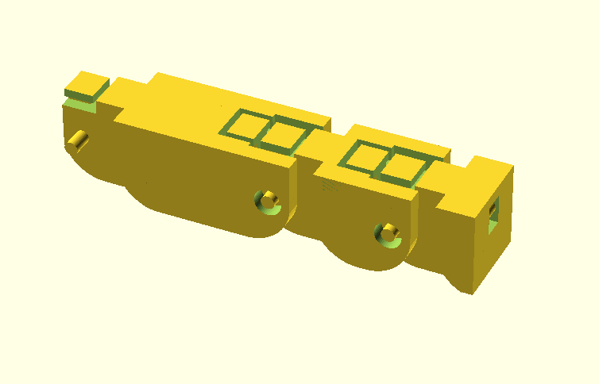

Figure 22: Model of finger

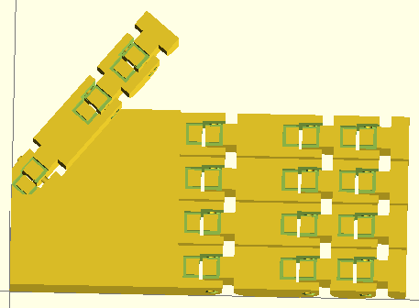

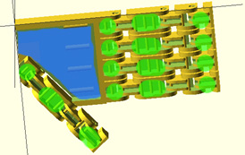

Figure 23: Model of fingers and hand. Top (left) and bottom (right) views. Bottom view has granular jamming region highlighted in blue, and silicon pad regions highlighted in green.

# Engineering Design

The first component for design was the motion of the fingers. Fingers will be controlled by a cable running down each finger attached to a servo motor (one per finger for the thumb, pointer and middle finger, and one shared between the ring and pinky fingers). To do this, we chose a material that would spool easily, would not stretch, and was strong and inexpensive, so we chose a 14 lb monofilament fishing line, since fishing line, in addition to not stretching, is designed to spool up well and to not tangle, all aspects that are valuable for our application. We chose 14 lb test line since that is far more than our motors can exert at maximum torque (2.5 N, or about half a pound). As the motor moves to a position, the cable will be reeled in, shortening the cable and causing the finger to curl. This design was chosen because it is relatively simple, inexpensive, small, and allows for uniform movement of the fingers. Servo motors were chosen to move the fingers because they are simple to control, strong enough for the purpose of this project, inexpensive, and small enough to fit multiple motors within the housing of the electronics. In order to straighten each finger, small elastic dental bands 5/16in size connect both segments of the finger around a joint and will straighten these segments if the servo is not curling the finger. These were chosen because they proved more than adequate after fatigue testing and are inexpensive and easy to replace should one fail.

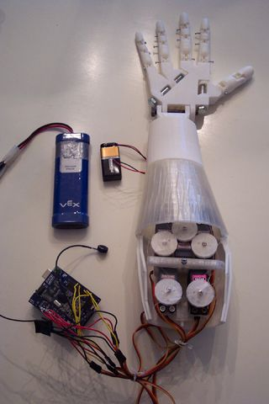

Figure 24: InMoov arm assembly showcasing the spools of line around the servos to move the fingers

A major concern for the design of the hand was the manufacturing of the fingers. Each finger has three segments which are supposed to be able to rotate 90o around their joints. The hand was designed to be low cost and relatively easy to create. In order to facilitate this, the hand will be 3D printed, with all of the parts of the fingers printed as a non-assembly model, in one piece. To accommodate the limitations of a 3D printer, the team needed to design around this. The team made sure that a printer would be able to print such an arrangement by printing three iterative prototypes of the finger. The spacing for each joint in a finger was widened to increase range of motion of the joints. Printed plastic joint pins were chosen to keep simplicity for manufacturing. These pins are able to be used on their own, but the use of bearings around the pin will increase their smoothness of motion. The end result after the manufacturability analysis proved that the smallest printed parts of the hand could be printed properly, demonstrating that joint pins are a feasible solution. The following motion analysis then refined the design of the finger, making it fully functional and ready to use.



Figure 25: A printed finger prototype demonstrating full range of motion.

Most of the electronics will be housed in the forearm of the device. The team will be using a forearm design that already exists in a current open-source project called the InMoov. Our project is an open source design and the group’s design focuses on a novel way to print the fingers and the inclusion of a granular jamming pad. Creating a design for the forearm housing is beyond the scope of the project, so in order to save time and resources, the team is using the forearm model from the InMoov design. However, the interior will differ. Whereas the InMoov has five motors, ours will have only have four, and will also include a pump and valve to control the granular jamming pad. These motor mounts are created using a method explained in “Assembly Models”.

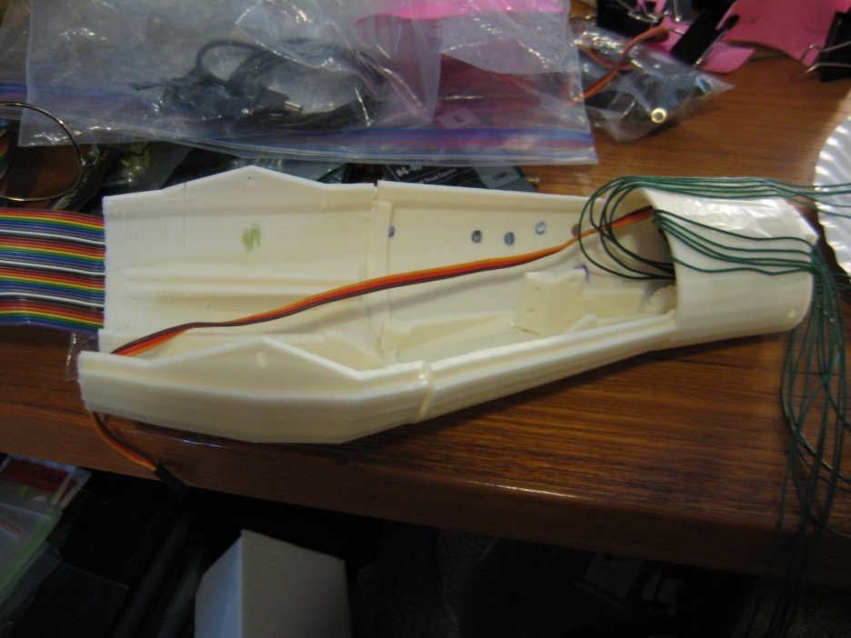

Figure 26: InMoov forearm housing

In order to control the motion of the finger, the team will be using an Arduino Uno Microcontroller because it has enough outputs for this project, is inexpensive and small, and because it will not be difficult to attach a wireless Bluetooth card for user input (discussed further in “Control Considerations”). To stop continued contraction of a finger that has already grasped an object, the team will be using a detection system. The system consists of four Hall Effect sensors, four magnets, and four springs, in a proven design that will be relatively simple to assemble, such that pressure at the fingers will pull the motors forward in their housing and move the magnets away from the Hall Effect sensors (discussed further in “Control Considerations”).

The design of the granular jamming subsystem involved the selection of types of materials and the number and locations of jamming pads. For the material selections, a silicone pad will be used because it is very flexible and relatively durable, making it ideal for this application.

Coffee grounds will be used as the granular material inside the pad. According to the article “Design and Analysis of a Robust, Low-cost, Highly Articulated Manipulator Enabled by Jamming of Granular Media” by Cheng et al., coarse ground coffee is the best material for use in granular jamming. Coarse ground coffee has both significant surface roughness and irregular, jagged features that increase interparticle friction. There is a relatively large size distribution which increases the interlocking ability of grains. Additionally, coffee contains some oil, which contributes to the bulk strength due to attractive capillary forces between particles. Ground coffee produced the most favorable combination of having a high strength-to-weight ratio in addition to large absolute strength. Furthermore, coffee grounds are inexpensive and very easy to obtain.

The number and layout of jamming pads has changed drastically over the course of the semester. Initially the team developed a design in which pads would be placed on various finger segments. After preliminary testing, the team determined that a large surface contact provided best results when picking up objects with a jamming pad. In order to greatly simplify the design, the team decided that it would be best to remove the pads on the finger segments and to instead have only one large pad on the palm of the hand. Instead of jamming pads along the fingers, the team is securing high-friction silicone pads to the fingers. These pads will be made of the same slip-cast silicone as the jamming pad, and will aid the fingers in grasping items, though they cannot replace the gripping capabilities of the granular jamming pad.

Figure 27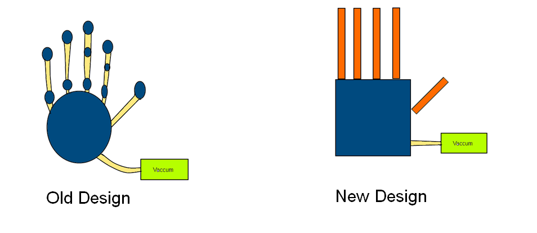: Comparison of old and new design layout of granular jamming pads

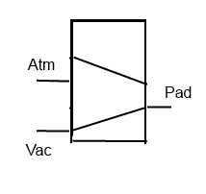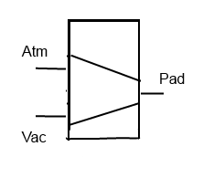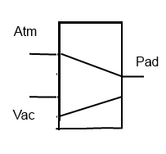The team will be using a micro brushless air vacuum pump because it can generate a large enough pressure difference needed for the granular jamming pad (as addressed in the technical analysis of granular jamming). Additionally it is a small pump, and will fit into the electronics housing. To control the flow of air to the jamming pad, the team will use a double solenoid valve. This valve was chosen because it will be simple to control and is effective in stopping any air flow to the jamming pad. This will allow the pad to stay in its jammed state without having the vacuum running continuously.

Figure 28: Illustration of the 3 different states of the valve allowing for suction of air out of the pad, having no flow, or returning pad to atmospheric pressure, respectively

## Electrical Considerations

From an electrical standpoint it is important to note that the pump and servo motors require different source voltages. The battery supplies 12 volts, which is suitable for the pump and solenoid valve but not for the servo motors, which require 6 volts. As a result, a regulator will have to be included to account for this change in voltage. Aside from this, the project is relatively simple from an electrical standpoint, with only four motors, one pump, one motor-controlled valve, and four Hall Effect sensors.

The first aspect of the electronics is how to ensure every component is getting appropriate power. To do this, the group decided to get a 12v battery and attach it in series to the Arduino (which can run on 12v or 6v), then to the pump, then to the solenoid, and finally to the regulator, which converts the 12v source to 6v and powers the servo motors. The reason why components are wired in series is to ensure that every component gets the correct voltage (since putting them in parallel would lead to a voltage drop, and the pump and solenoid not getting enough power). A simplified schematic of the power layout can be seen here:

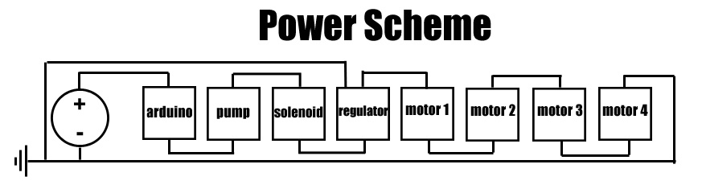

Figure 29: Power Layout

Motor, solenoid valve, and pump control is a little more complex. While the Hall Effect sensors can be plugged directly into the Arduino with no issues, the other components actually draw too much current for the Arduino to put out without getting damaged. The solution for this is to attach the signal wire of these components to the Arduino, so that it can give them commands, while these components actually draw their power directly from the battery, rather than through the Arduino’s pins. This is why, in the power scheme, everything is shown as being powered in series, rather than having all components branching from the Arduino (as they would if they were getting powered through the controller). Because the pump has a brushless motor, it uses the same type of circuit for this application as the solenoid valve. The motors, due to their brushed motors, require a different circuit with an additional capacitor (this is to prevent sparks from the brush from damaging the other components).

The pump and solenoid control circuit requires a transistor (a device that converts the electronic signal given by the Arduino to electrical power—basically allowing the signal wire to control voltage and therefore speed or position, the specific transistor uses is the TIP120 transistor, which works well with Arduinos), a 1 KΩ resistor, and a diode (a device which only lets current flow through it in one direction, preventing the solenoid or pump from forcing power back into the other components and damaging them).

The way the circuit is laid out is as follows: The “emitter” pin of the transistor is grounded along with the Arduino. This ensures that you will have a common ground, which, while it is not important for the solenoid, which is not sensor-controlled, is important for other aspects of the arm, such as the motor control. This is because having a common ground means that all the sensors will exist at the same “zero” point, and that there will never be an issue where one sensor has more electrical noise than another (which makes it look to the controller like it is sensing more). The base leg of the transistor is attached to a PWM signal pin of the Arduino through the resistor. This allows the Arduino to tell the transistor how much power to provide to the device, and the resistor is there to protect the Arduino in case of an electrical short. The Collector leg of the transistor is then attached to the solenoid/pump ground, and the battery is connected to the power of the solenoid/pump through the diode, which prevents the solenoid from forcing current back into the system (in motors this is a common problem with backdriving—which makes the motor act as a generator).

One of these circuits is required for the solenoid, and one is required for the pump. For both of these devices, the power source is just the battery. The schematic for this circuit is shown on the following page:

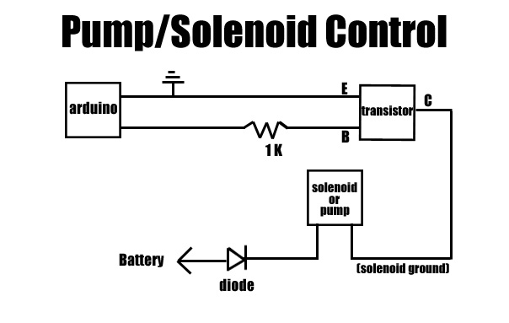

Figure 30: Pump/Solenoid Circuit Layout

The motor control circuit is very similar, except that it has a capacitor as well. This is because the servos have internal brushes which can cause sparks within the motor. While this is not a huge issue for the motor itself (though it does wear the motor out faster), it is a problem if those sparks result in power surges to the Arduino. To solve this problem, a 1 μF capacitor is soldered across the poles of the motor. This capacitor will then prevent rapid power changes within the circuit due to brush sparks. The diode in this circuit is moved as well, where before it was between the power source and the motor, now it is between the motor and the ground. Its purpose is unchanged however, and placing it in a new position has no real effect on how the circuit functions.

Again, one of these circuits is required for each motor, however where the solenoid and pump were drawing their power from the battery, the motors draw theirs from the voltage regulator after it has converted voltage to a more appropriate 6 volts. The circuit diagram can be seen below:

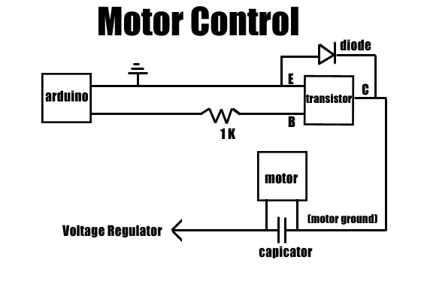

Figure 31: Motor Circuit Layout

Control Considerations As can be seen in the electrical diagram above, the Hall Effect sensors will receive power from the Arduino, as well the servo motors. The pump will be powered directly from the battery and controlled via the Arduino. By using Hall Effect sensors and springs in the motor mounts, finger pressure can be measured as a displacement.

The principle behind this design is quite simple. As the finger contacts an object, that object will resist the finger’s closing. As a result the cable will begin to offer more resistance to getting reeled in by the motor. If the motor is free to slide, it begins to pull itself forward, toward the hand. By mounting the motor with a spring in the front, it will be pushed to the back of its housing when in a neutral state, but when the finger contacts an object, the motor will pull itself forward, compressing the spring. The more force exerted at the finger, the more the motor will pull forward. By placing a sensor at the back of the motor housing (consisting of a magnet attached to the motor via a small piece screwed to the motor wings, and a Hall Effect sensor at a stationary point of the forearm), distance that the motor has been pulled forward can be sensed via the change in measured magnetic field (measurements will be higher at a neutral state, and drop when the finger is pressing into an object). This means that pressure can be reasonably measured, accurately and inexpensively, while having absolutely no electronic components in the hand itself.

**Figure 32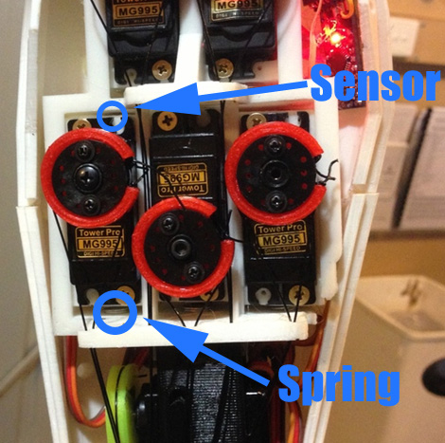: Proposed sensor setup. (Image source: Inmoov 5)**

This design has the benefit of making the hand itself more robust (since there will be no wires potentially getting crimped in moving joints) with more room for soft pads. It will also make the hand water resistant, which is greatly useful for a number of household tasks (for example, if activities, such as preparing food, require sanitation, the hand can simply be washed carefully with household soap). Finally, keeping all the active components of the design (rather than the passive parts such as the wires and the jamming pad itself) contained within the forearm means that they are easily accessible for replacement or repair, something that cannot be said of sensors that snake their way through many moving parts.

As far as the pump control is concerned, there will be two ways to activate the pump and engage the granular jamming pad. The first is to add a simple program that states when enough fingers are in contact with an object (as determined by the Hall Effect sensors), the vacuum will automatically activate. The second is to allow the user to choose to activate the pump, either by physical button or via Bluetooth command. Having the first system in place allows the granular jamming pad to engage and improve on grip that the user is already exerting. Having the second system in place allows the user to have more control over the granular jamming pad, making it useful in situations where items are too small or fragile to manipulate with the fingertips. Instead, the user can simply orient the granular jamming pad and run the pump themselves.

Both of these methods will be supported. Whether the second method will be supported via a button or Bluetooth command (or both) will be ironed out during final development. Both procedures require very minor design adjustments that will not alter fundamental design.

Another aspect of supporting Bluetooth is that it would allow the user much more control of the prosthetic in general. Going too far into programming and control of the device is beyond the scope of the project, but since it is open source, users can build more and better control interfaces onto the team’s established control framework. Bluetooth support would allow the user to seamlessly switch between different closing speeds for the fingers, different pressure sensitivities in the Hall Effect sensors, and allow for better control of the granular jamming pad. Therefore, Bluetooth capability is being strongly considered in the final design, and even though it may or may not be implemented by the team, the prosthesis will be designed around being able to support this method of control.

Safety Considerations As far as safety is concerned, nothing in the design is particularly dangerous. The pump is quite small, the motors do not exert enough force to injure someone, and the battery, while it does represent a small fire hazard, is designed to be safe.

The only major issue is that the arm is not designed to be waterproof. While the hand is water resistant, if a large amount of water gets into the forearm it will damage the electronics. This risk can be mitigated by shrinkwrapping the Arduino and insulating the wire contacts well (and possibly using waterproof servos) however, the chances of fully waterproofing the arm are quite low and as a result, it will never be appropriate to submerge it in water (even though the hand alone can be submerged with no issues). It will, however, be reasonable to say that the hand can be made relatively water resistant, so that going out on a somewhat rainy day will not damage the electronics.

One other safety aspect that may be explored is the idea of adding a “kill switch”, making all electronics shut off. This might be an appropriate addition if certain problems are encountered as the hand is used, for example, if the hand closes around something and will not open, or if the pump is stuck continuously running. This “kill switch” would consist of a switch at the battery, flipping it will cut off all power to the Arduino and electronics. This kill switch will be implemented if the prototype displays any issues with continuously running actuators (since adding it into the device will be trivial). The same function could also be controlled via Bluetooth (though if the device is not listening to commands, this may be ineffective).

# Professional Drawings/Assembly Models





Figure 33: The First iteration of the finger assembly in OpenSCAD.

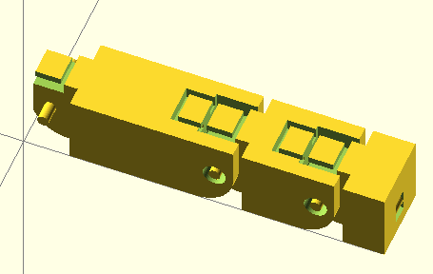 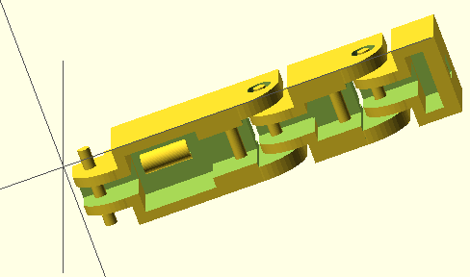

Figure 34: The second iteration of the finger assembly in OpenSCAD. Joints are farther apart and bearing allowances are created.

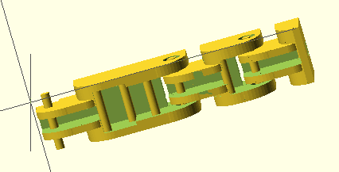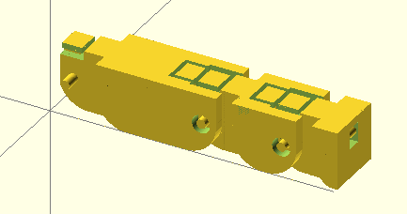

Figure 35: The third iteration of the finger assembly in OpenSCAD. This finger has rounded, more spaced, joints to allow for a more realistic range of motion, and redesigned cable guides.

Since the design is to be 3D printed, formal technical drawings with dimensions are rendered unnecessary. Normally a dimensioned drawing is needed in order for the device to be manufactured, but with 3D printing, the model is simply exported as a .STL file and all dimensions are preserved when it is printed.

Therefore, in order to ensure that the modeled parts will fit correctly with motors, etc, one does not have to use technical drawings. Instead, one can simply model the motor itself and then subtract its shape from the printed model. As long as the motor model is correct (and a tolerance is included for the printer), the result will be a motor mount that always works, without having to change dimensions manually. Here is the motor file created for this process:

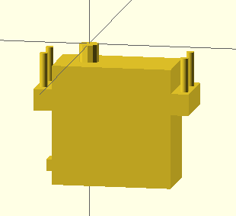

Figure 36: Motor Condition

Interestingly, since OpenSCAD is script-based, this motor was written to call several arguments. This configuration is called by StandardServoMotor(true,2,true,.4), where the first argument denotes bolt direction (this is up), the second denotes hub type (this is the base metal hub), the third denotes where the module centers (this is centered at the hub), and the fourth represents printer tolerance (currently set at a fairly snug 0.4 mm).

Changing the configuration to StandardServoMotor(false,3,false,1) yields:

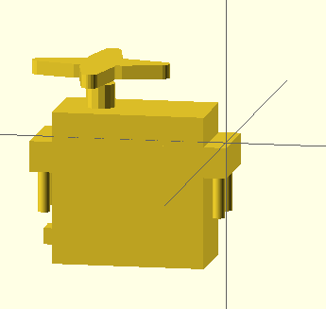

Figure 37: New Motor Condition

Note that the bolts are now facing down, the hub has changed to a different style, the motor now centers at the right-front corner, and though it is hard to see, the features are slightly larger.

Creating motor mounts with this method is trivial. Simply take a rectangle and subtract the motor from it, and a motor mount designed around all features of the motor is generated.

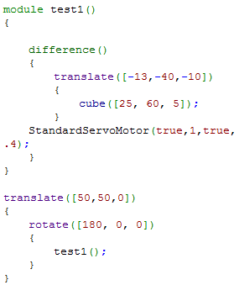

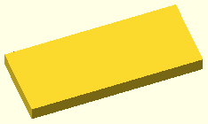

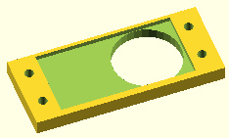

Figure 38: A motor mount (bottom), the block it was generated from (top), and the few lines of code required to do it (right)

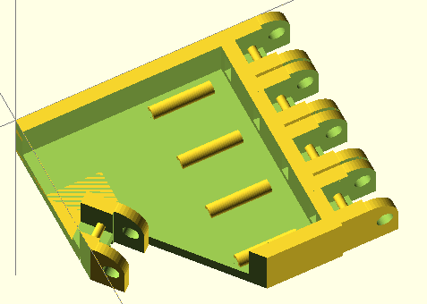The forearm design for this project is simply taken from the InMoov, and mounts are being added via the method outlined above. The palm design is as follows:

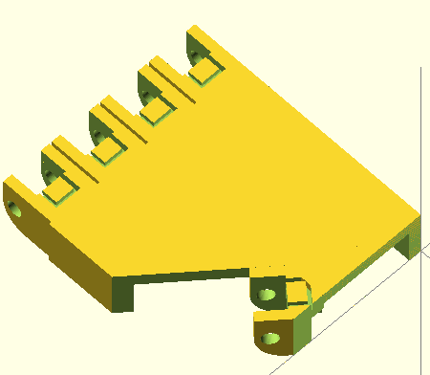

Figure 39: Palm model from top (left) and bottom (right).

It contains mounts for the four fingers and the thumb, as well as cable guides to prevent the cables getting tangled. The fully assembled hand model is as follows:



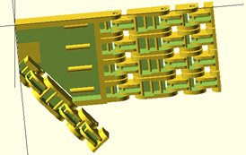

Figure 40: Hand model from top (left) and bottom (right).

**Conclusion**

The 3-D printed granular jamming prosthetic hand will combines a non-assembly 3-D base, with the added functionality granular jamming pads, and in this last phase the group has ironed out most design and control issues. The hand will be printed with ABS plastic (even though both ABS and PLA are valid choices) because ABS has superior wear resistance. Also, the fingers and palm will be printed in whole because the analysis shows that they are strong enough to withstand forces that the hand will reasonably encounter.

The product will include granular jamming technology. There are small objects that cannot be picked up by the hand, due to its limited dexterity. Because of such inconvenience, granular jamming will be implemented. When the hand senses that enough fingers have contacted an object (or if the user chooses to activate the pad), the prosthetic will assist the user via its granular jamming mechanism. The vacuum will activate to make the pad rigid, allowing for better grip, or for the user to lift relatively small objects. This technology will be beneficial to our design because it makes up for a lot of the lost functionality due to the fact that the hand only uses four motors (as opposed to the dozens of motors in state-of-the-art prosthetics).

Finger movements and granular jamming will be controlled by a microcontroller. Controlling will be done with four Hall Effect sensors that send signals to activate granular jamming or fingers. The device will also support Bluetooth communication, should the user choose to implement it.

The 3-D printed granular jamming prosthetic hand will be a design that will combine a few technologies that are available but also reliable. It will be a beneficial design which can be accessed by every amputee.

# Gantt Chart

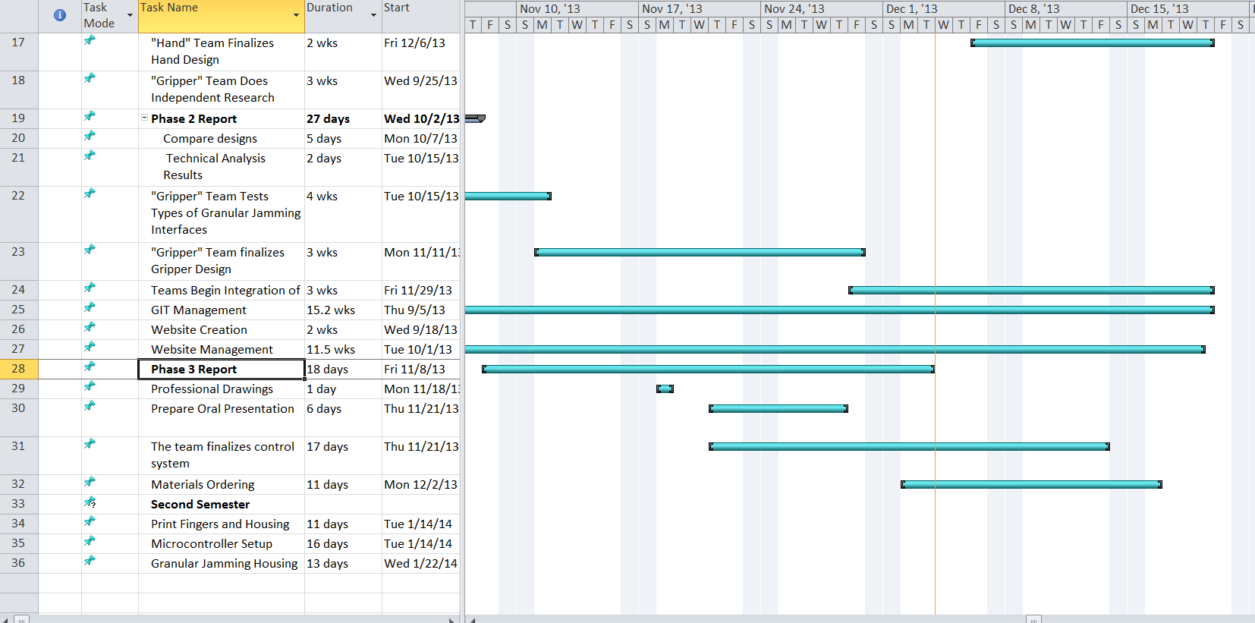

# Nugget Chart

|  |
| --- |
| **Project Objectives** |
| The objective is create an open-source, affordable and high-functioning prosthetic hand. The hand will be similar in size and weight to a human hand, looking similar as well. Primary tasks include picking up and putting down objects around the house and also opening different doors and knobs. The use of individual fingers is important too as another task set forward is pointing and computer mouse clicking. The project also looks to incorporate granular jamming technology to help with grabbing and holding of objects for the user. |
|
|
|
|
|
|
|
|
| **Joint Pin Analysis** |
| Manufacturability analysis found that the finger can be printed as a non-assembly model so long as tolerances are made large enough, and so long that measures can be taken to prevent excessive warping in the joint pins. Without bearings, the finger is perfectly functional although it does tend to rattle. It can even be possible to add bearings on a case-by-case basis, where hands with relatively non-warped pins can be provided as-is, and those with slight defects can be corrected with bearings. Regardless, there seems to be no issue with printing the finger as it is currently designed, and therefore design can move forward while assuming that the joint pins are plastic, and that the model is printed in one piece. |
|
|
|
|
|
|
|
|
|
|
|
| **Finger Strength Analysis** |
| An important piece of this project is the material in which the hand is printed. To help with material selection, the team did an analysis of a force on a finger. The finger was modeled as a static body using a square cross section. A force of 2 kilograms was chosen. This was chosen because if the whole hand was carrying a grocery bag or briefcase, the force would be distributed to the four fingers. This means the 2 kilogram force on one finger is equivalent to 8 kilograms held by the whole hand. The team decided this was a sufficient weight to symbolize what someone would carry. It was determined that maximum stress (251.6kPa) would occur on the inside of segment AC, because the bending stress and normal stresses are additive. |
|
|
|
|
|
|
|
|
|
|

|  |
| --- |
| **Granular Jamming Analysis** |
| Several things were observed during testing. First, the team saw first-hand that granular jamming can and is able to pick up various household object. Additionally, it was determined that coffee grounds were better for picking up objects than the plastic beans. This is because the granule size of ground coffee is smaller than that of the plastic beans. Particles can more easily wrap around an object the smaller they are, so coffee grounds are a better option. Finally, it was observed that the balloon could only pick up objects it was able to have a lot of contact surface area and wrap well around the object. This observation led to a change to the layout of the granular jamming pads. Originally, pads were to be in various parts of the fingers. After the above testing, the team determined that there will only be one large jamming pad in the palm of the hand, because it will have enough surface area to better pick up objects. |
|
|
|
|
|
|
|
|
|
|
|
|
|
| **Control and Electrical Analysis** |
| The hall effect sensors will connect directly to the Arduino. The pump, valve, and motors will have protective circuits and only use the Arduino as a source of commands, not power.  The control system works as follows: As the finger contacts an object, that object will resist the finger’s closing. As a result the cable will begin to offer more resistance to getting reeled in by the motor. If the motor is free to slide, it begins to pull itself forward, toward the hand. By mounting the motor with a spring in the front, it will be pushed to the back of its housing when in a neutral state, but when the finger contacts an object, the motor will pull itself forward, compressing the spring. The more force exerted at the finger, the more the motor will pull forward. By placing a sensor at the back of the motor housing (consisting of a magnet attached to the motor via a small piece screwed to the motor wings, and a Hall Effect sensor at a stationary point of the forearm), distance that the motor has been pulled forward can be sensed via the change in measured magnetic field (measurements will be higher at a neutral state, and drop when the finger is pressing into an object). This means that pressure can be reasonably measured, accurately and inexpensively, while having absolutely no electronic components in the hand itself. |
|
|
|
|
|
|
|
|
|
|
|
|
|
|
|
|
|
|
|
|
|
|

# 

# Bill of Materials

|  |  |  |  |
| --- | --- | --- | --- |
| **Part** | **Quantity** | **Cost** | **Total** |
| 100 piece cylinder magnets | 1 | $3.99 | $3.99 |
| Hall effect sensors | 10 | $0.73 | $7.30 |
| Steel helical Compression Spring | 5 | $4.99 | $24.95 |
| Arduino UNO | 1 | $27.00 | $27.00 |
| Servo Motor | 7 | $8.95 | $62.65 |
| 25 1/4th inch stainless steel screws | 1 | $6.49 | $6.49 |
| 30 pack Small Ball Bearings | 1 | $14.95 | $14.95 |
| 30 bag 5/16" rubber bands | 1 | $4.25 | $4.95 |
| 6' Silicone Air Line Tubing | 1 | $3.33 | $3.33 |
| position pneumatic valve | 1 | $39.95 | $39.95 |
| 1 pint Platex Mold Latex | 1 | $36.00 | $36.00 |
| Flexible Pneumatic Tubing | 1 | $10.50 | $10.50 |
| Detailed Plastic Acrylic based | 5 | $2.99 | $32.40 |
| Micro Brushless Air Vacuum Pump | 1 | $52.25 | $52.25 |
| Voltage Regulator (12v to 6v) | 1 | $3.45 | $3.45 |
| TIP120 transistor | 6 | $0.70 | $4.20 |
| 1K resistor | 6 | $0.10 | $0.60 |
| Diode 1N4004 | 6 | $0.20 | $1.20 |
| 1 uF ceramic capacitor | 4 | $0.10 | $0.40 |
| **Total Price** |  |  | **$336.56** |

# Works Cited

Brown, Eric, Nicholas Rodenberg, John Amend, Annan Mozeika, Erik Steltz, Mitchell R Zakin, Hod Lipson and Heinrich M Jaeger. "Universal robotic gripper based on the jamming of granular material."*Proceedings of the National Academy of Sciences*, 107. 44 (2010): 18809--18814. Print.

Cheng, Nadia G, Maxim B Lobovsky, Steven J Keating, Adam M Setapen, Katy I Gero, Anette E Hosoi and Karl D Iagnemma. "Design and analysis of a robust, low-cost, highly articulated manipulator enabled by jamming of granular media." (2012): 4328--4333. Print.

Freeland A, Psonak R. Traumatic Below-elbow Amputations.*ORTHOPEDICS.* 2007; 30: [[link]](http://www.healio.com/orthopedics/journals/ortho/%7Bd8543c5d-935b-46b7-bc35-482cb8921806%7D/traumatic-below-elbow-amputations)

"Inmoov 5 servo finger sensor by Jhack - Thingiverse." Thingiverse.com, 2013. Web. 5 Dec 2013. <<http://www.thingiverse.com/thing:92352/>>.

Jamshidian, Majid, Elmira Arab Tehrany, Muhammad Imran, Muriel Jacquot and St&Eacute;Phane Desobry. "Poly‐Lactic Acid: Production, Applications, Nanocomposites, and Release Studies."*Comprehensive Reviews in Food Science and Food Safety*, 9. 5 (2010): 552-571. Web. 5 Dec 2013.

Kulley, Marlowe. "Statistics." *Biomed.brown.edu*. Brown University, n.d. Web. <http://biomed.brown.edu/Courses/BI108/BI108_2003_Groups/Hand_Prosthetics/stats.html>.

"Polylactic Acid (PLA, Polylactide) - Material Properties Data :: MakeItFrom.com." *Makeitfrom.com*, 2013. Web. 4 Dec 2013. <http://www.makeitfrom.com/material-data/?for=Polylactic-Acid-PLA-Polylactide>.

"20 Pcs 3mm Inner Dia Stainless Steel Deep Groove Ball Bearing." *Sourcingmap.com*, 2013. Web. 5 Dec 2013. <http://www.sourcingmap.com/20-pcs-3mm-inner-dia-stainless-steel-deep-groove-ball-bearing-p-475350.html?utm_source=google&utm_medium=froogle&utm_campaign=usfroogle&gclid=CN7mlLT2zroCFc-Y4Aod8xUAHQ>.

Astley, Tom. "Hypermobility Awareness & Assessment." *TA Physio*, 2013. Web. 4 Dec 2013. <http://taphysio.wordpress.com/2012/10/23/hypermobility-awareness-assessment/>.

Unknown. *ABS Material Data Sheet*. 1-2, 2013. E-book.

Image Source 1: Unknown. Untitled. Digital image. 2013. Web. 5 Dec 2013 <http://4.bp.blogspot.com/-XRcu7dojfAA/TWfD3OcpA-I/AAAAAAAAD-I/ww5XaBq-wYQ/s1600/IMG_1268.JPG>.

Image Source 2: Unknown. Untitled. Digital image. 2013. Web. 5 Dec 2013 <http://www.theironbuzz.com/wp-content/uploads/2012/09/dsc_9348.jpg>.